**Gyroscope Technology**

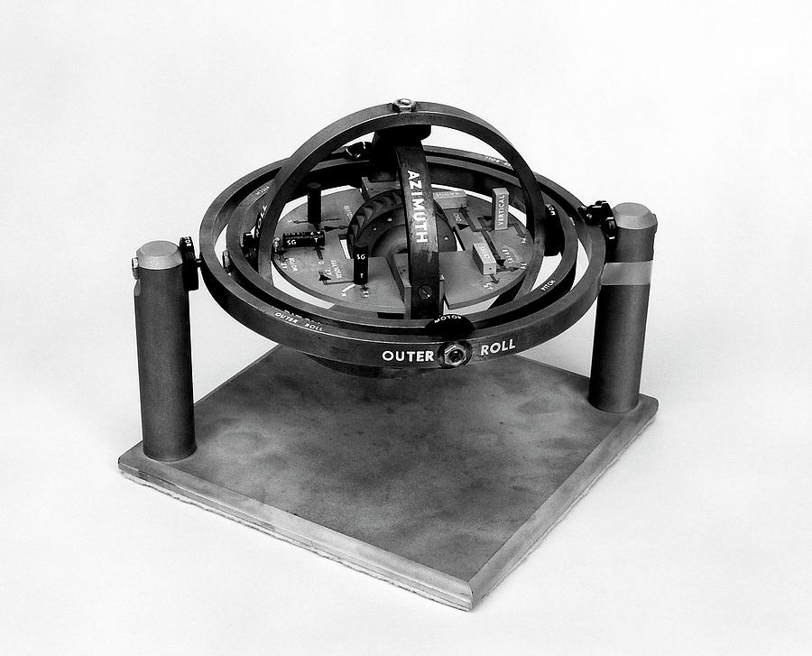

*Image ​Source:* [*https://en.wikipedia.org/wiki/Ring_laser_gyroscope*](https://en.wikipedia.org/wiki/Ring_laser_gyroscope)

**What Is a Gyroscope?**

Gyroscope, a device containing a rapidly spinning wheel or circulating beam of light that is used to detect the deviation of an object from its desired orientation. Gyroscopes are based on the law of conservation of momentum. A gyroscope senses change in orientation of a device, and when paired with an accelerometer, is an excellent tool for measuring the orientation of an object in 3D space. Gyroscopes determine angular velocity (ω) typically measured in radians/second. The integration of angular velocity provides orientation information (if an initial orientation is provided or a value can be assumed) across three axes: pitch, roll and yaw. A gyroscope enables tracking of the twists, turns and rolls of an object in motion.

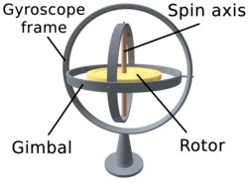

*Image ​Source:* [*https://en.wikipedia.org/wiki/Gyroscope*](https://en.wikipedia.org/wiki/Gyroscope)

Gyroscopes were invented a century ago and have been used as references to know the inertial state of a moving body. Gyroscopes are used in compasses and automatic pilots on ships and aircraft, in the steering mechanisms of torpedoes, and in the inertial guidance systems installed in space launch vehicles, ballistic missiles, and orbiting satellites.

The classic gyroscope consists of a spinning wheel or disc which works based on the principle of conservation of angular momentum. The rotation of the spinning axis remains unaffected due to the conservation of the momentum.

**Types of Gyroscopes:**

1. **Ring Laser Gyroscope (RLG):**

Ring Laser Gyroscopes operate on the Sagnac Effect. In this, a split beam of light traveling the same path in opposite directions will undergo phase changes when the whole apparatus experiences angular velocity. A laser is split into two along two paths of equal length and is received at a detector. As the device rotates clockwise, the beam moving clockwise effectively travels a slightly longer path and slows down its reception by the detector. The counterclockwise beam is traveling against the rotation, effectively shortening the path, increasing its speed relative to the other laser. The opposite effect occurs under a counter-clockwise rotation. By measuring the phase changes while the device is rotating, angular velocity can be ascertained.

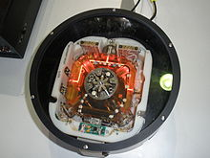 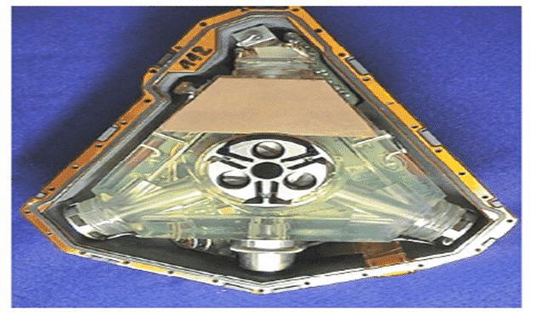

**Ring laser gyroscope**

*Image ​Source:* [*https://en.wikipedia.org/wiki/Ring_laser_gyroscope*](https://en.wikipedia.org/wiki/Ring_laser_gyroscope)

*Image ​Source:* [*http://electricalfundablog.com/ring-laser-gyro/*](http://electricalfundablog.com/ring-laser-gyro/)

*Uses:*

* Inertial navigation systems in :
* military aircraft,
* commercial airliners,
* ships
* spacecrafts.

The ring laser gyroscopes used in ParAlign are highly restricted because they are among the world’s most accurate—and they can be used for sensitive applications. ParAlign is a featured component of Prüftechnik’s Peak Roll and Geometrical Alignment (Peak RGA) service, and a big reason is its exclusive military-grade gyroscope technology. This same technology has been used in aerospace navigation systems, including NASA’s space shuttle program.

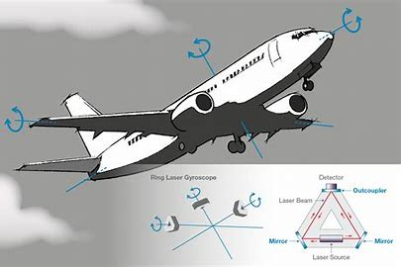

**Ring Laser Gyroscopes in Airplanes**

*Image ​Source:* [*https://www.opticsbalzers.com/en/applications/ring-laser-gyroscope.html*](https://www.opticsbalzers.com/en/applications/ring-laser-gyroscope.html)

***Brief Note about Sagnac Effect:***

Sagnac principle, as derivation of the general relativity theory, states that two counter-propagating optical beams propagating in a ring structure change their relative phase if the ring is rotating; thus, it is possible to relate the phase change to the angular speed of the ring. As an example, by considering an open circular light path of a few centimetres and a rotational speed of one revolution per second, according to the Sagnac effect, the optical beam's path difference is 0.00000025 mm, which is too small for angular velocity detection.

1. **Dynamically Tuned Gyroscopes (DTG):**

A dynamically, a mechanical gyroscope, contains a rotor that is held between extremely free pivots. At a particular speed called the tuning speed, the rotor is free from torque due to the rotation and can be used as a conventional or ideal gyroscope to measure rotation/rotary displacement from gimbal.

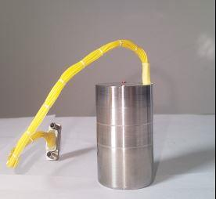

*Image ​Source:* [*https://www.ericcointernational.com/gyroscope/dynamically-tuned-gyroscope/er-e6-dynamically-tuned-gyro-for-oil-and-gas.html*](https://www.ericcointernational.com/gyroscope/dynamically-tuned-gyroscope/er-e6-dynamically-tuned-gyro-for-oil-and-gas.html)

1. **Fiber Optic Gyroscope (FOG):**

Fiber Optic Gyroscope also uses the Sagnac effect, using multiple coils for the light to travel. The light beams are propagated by an external laser. The light beam propagating in the same direction as the rotation will have a somewhat longer path delay than the beam that’s running against the rotation. This results in a differential phase shift, that is effectively multiplied by each additional coil that the Fiber Optic Gyroscope uses. This multiplication allows the FOG to have an increased sensitivity.

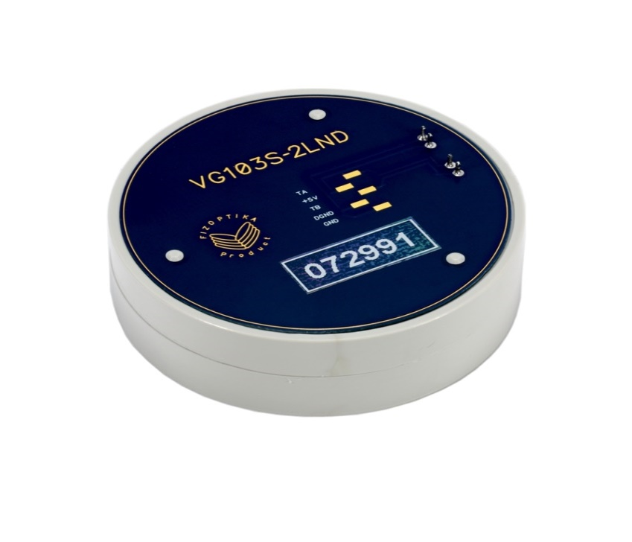

*Image ​Source:* [*https://fizoptika.com/fiber-optic-gyro-series-vg103s/*](https://fizoptika.com/fiber-optic-gyro-series-vg103s/)

***Uses:***

* High-shock applications such as gun pointing systems
* Remotely-operated vehicles and autonomous underwater vehicles
* Surveying equipment
* Inertial navigation systems of guided missiles
* High-performance space applications
* Fiber optic gyrocompasses for navigation systems

1. **MEMS-Based Gyroscope (MEMS):**

MEMS (MicroElectroMechanical Systems) use a combination of mechanical oscillation and Coriolis force. (The Coriolis force is the inertial force that acts in a direction perpendicular to the rotation axis.) Inside the MEMS gyro, imagine a capacitive block that oscillates at a fixed rate in the opposite phase with another block. As the device rotates, the blocks’ Coriolis forces move them slightly in opposite directions (both perpendicular to the rotation axis), due to the blocks’ phase differences. This difference in force changes the capacitance of the plate underneath it to measure the overall angular rate of an object. MEMS gyroscopes are typically 3-axis. Consumer grade gyros tend to be cheaper whereas the industrial or automotive ones are costlier, which operate at wider temperature ranges and are designed to be more efficient keeping in mind the safety requirements as well.

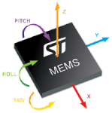

*Image Source:* [*http://linuxgizmos.com/new-embedded-features-in-linux-kernel-3-9/*](http://linuxgizmos.com/new-embedded-features-in-linux-kernel-3-9/)

***Uses:***

* Portable consumer electronics such as tablets, smartphones, smart-watches, game controllers, AR/VR headsets and robotic cleaners
* Smart technologies in homes, cities and cars
* Industrial and automotive applications, such as GPS systems
* Mobile and VR gaming applications
* IMU (inertial measurement unit)
* Optical image stabilization in cameras

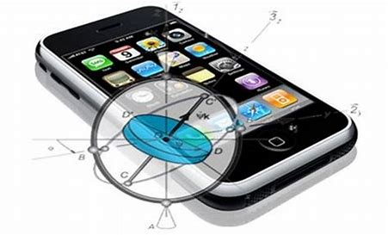

*Image Source:* [*http://deskarati.com/2012/04/28/history-of-the-gyroscope/*](http://deskarati.com/2012/04/28/history-of-the-gyroscope/)

**Application of Gyroscope in GPS:**

Inertial Navigation Systems (INS) are navigational systems capable of calculating position, either relative to some reference system/point or to absolute coordinates. An INS system is composed of at least three gyros and three accelerometers enabling the system to derive a navigation solution. It is a device that uses a computer, motion sensors or the accelerometers and rotation sensors or the gyroscopes to continuously calculate by dead reckoning the position, the orientation, and the velocity of a moving object without the need for external references. This navigation solution contains the position (latitude, longitude). Most INS systems today output heading, pitch, and roll. Some systems also include heave, sway, and surge.

The concept behind an INS system is the measurement of changes in relative motion (through the measurement of acceleration) to project a changing position in some inertial reference frame over time. The main component of an INS system is its inertial measurement unit (IMU). This mechanism is composed of three orthogonal gyros and three orthogonal accelerometers. Inertial Measurement Units (IMUs) are electronic devices used for detection of the current object orientation. They measure changes in an object's rotation and acceleration. Such sensors usually consist of at least two different types of sub-sensors; first type is an accelerometer measuring linear acceleration and the second is a gyroscope measuring angular acceleration value. Often the inertial sensors are supplemented by magnetometers.

***Inertial Navigation Systems*** (***INSs) are used on:***

* Mobile robots
* Vehicles such as ships, aircraft, submarines,
* Guided missiles
* Spacecraft

***How it works?***

Assume an IMU lying horizontally on a surface. The forces acting on the IMU would be the Earth’s rotation acting on the vertical gyro and the Earth’s gravity acting on the vertical accelerometer. Given IMU a push forward, the accelerometer having its sensitive axis pointing forward would measure this acceleration. None of the other accelerometers would measure any change. The system would then perform basic deduced reckoning (dead reckoning) to derive an assumed position. A positional error is propagated over time due to the inherent inaccuracies of any inertial sensor. While inertial navigation systems are undoubted good at measuring position, orientation and dynamics, the one Achilles heel of basic un-aided inertial navigation systems is drift. In order to get around this inherent positional drift in INS systems, the survey system is usually augmented by some sort of aiding device. For surface applications, an aiding device could be a global positioning system (GPS).

**Other Applications of Gyroscope:**

One of the main problems during autonomous mobile objects’ development is the problem of precise navigation. In order to navigate the object it is required to know the exact position and orientation of the object with respect to the environment. Creation of a sensor system capable of an environment perception as well as monitoring inner object parameters is an important problem in the unmanned mobile objects field.

Access to more accurate orientation information has wide-ranging practical applications:

* Helping a land based robot account for obstacles it runs over
* Translating a person’s real world movement into a virtual world
* Helping to orient an aircraft in flight
* Stabilizing the pictures that we click using our cameras
* Guiding an unmanned aircraft during flight

Life without gyroscopes is unimaginable. Gyroscopes are employed in many critical applications like guiding ballistic missiles, guiding the process of building tunnels, fire control systems abound ships, satellite navigation etc.